Sky Telescope
EarthSky
Eyes on the Sky
Have your star charts with.
Complete the location of 1st magnitude stars.
Read about M Objects.
The Messier objects are a set of astronomical objects first listed by French astronomer Charles Messier in 1771
Messier was a comet hunter, and was frustrated by objects which resembled but were not comets, so he compiled a list of them. He never found a new comet.
On your star charts place a small circle around the following M objects. If not there still make a circle for the location and label the M Object.
M1 The Crab Nebula RA 5:35 Dec 22 degrees
M20 The Triffid Nebula RA 18:02 Dec. -23 degrees
M31 The Andromeda Galaxy RA 0:42 Dec 41 degrees
M42 The Great Orion Nebula RA 5:35 Dec. - 05 degrees
M45 The Pleiades RA Dec Find it. It’s next to Orion.
M57 The Ring Nebula RA 18:55 Dec. 33 degrees
M104 The Sombrero Galaxy RA12:40 Dec. -11 degrees
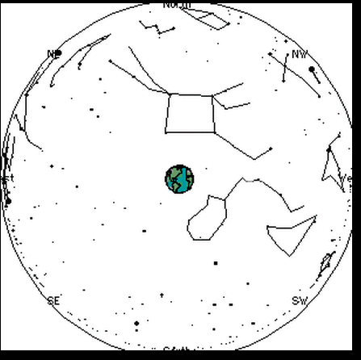

Link
Celestial Sphere and Constellations Unit
Star Map
Star Maps in your text. pages 714-717

The human eye can see about 6000 stars without aid.

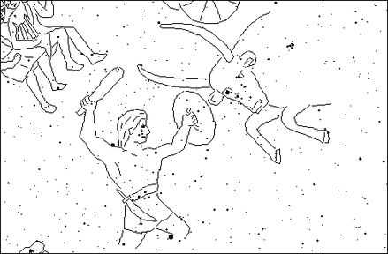

Constellations a pattern of stars in the sky.
Many where described by the ancient Greeks and Babylonians, although the southern hemisphere has many that were "created" by European explorers a few centuries ago.
The ancients thought of the constellations as representing mythical figures such as Orion the Hunter and Taurus the Bull.
A tool to navigate the sea or desert.
1. Why the stories about the figures in the sky?

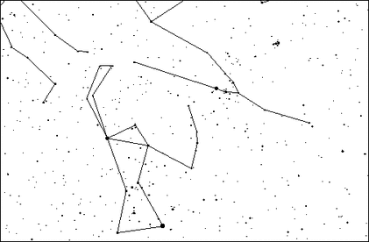

Nowadays we often think of constellations as "stick figures", consisting of lines connecting the major stars.

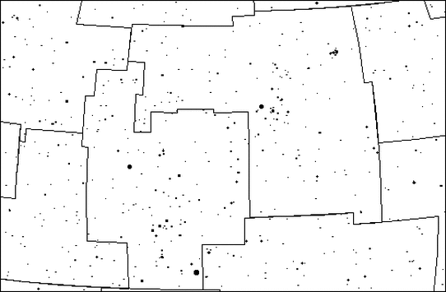

88 regions
Astronomers now think of a constellation as one of 88 regions that divide up the sky and completely cover it.
Any object can now be said to lie in one constellation or another.
2. What letter do you see in Taurus's head?
Objects within constellations are found by being able to locate a constellation.
3. Tonight the planet Mars is found in the constellation Taurus. How would you locate Mars?
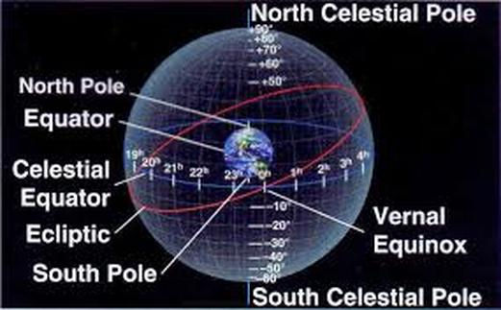

Celestial Sphere location system that pinpoints the location of objects in the sky.
4. Where does Mr Larsen live?
It is therefore useful to think of the stars as being "painted" on the interior surface of a large sphere centered on the Earth, called the celestial sphere.
5. What does the celestial sphere do?
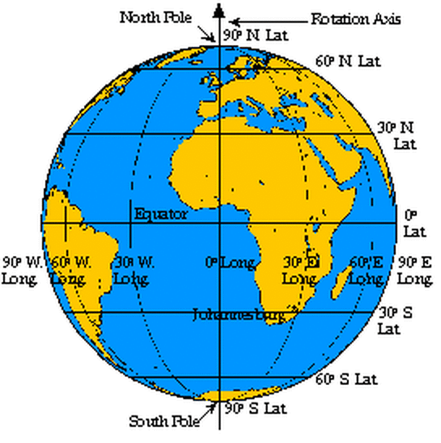
Latitude and Longitude a map.
Celestial Sphere is a map in the sky.
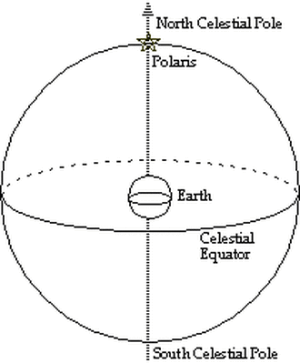
North Celestial Pole
The North Celestial Pole is the point on the celestial sphere directly above the Earth's North Pole.
Polaris is therefore also called the North Star.
6. How do you find the North Star?
Celestial equator is directly above the Earth's equator.
7. How many times is the sun on the celestial equator?

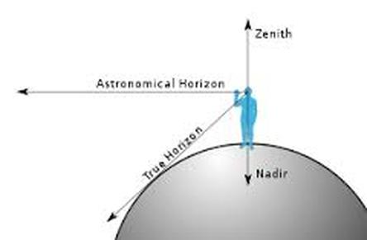
Zenith For any position on the surface of the Earth, the point on the celestial sphere that is directly overhead is called the zenith.
8. What structure is at the zenith in the classroom?
9. Where will the zenith be in the sky tonight?

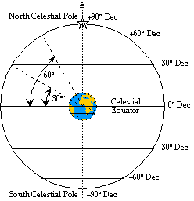
Declination corresponds to latitude, and is measured in the same way, but relative to the celestial equator (0° dec).
Measured in degrees. The north celestial pole is at 90° north declination (+90° dec). The south celestial pole is at 90° south declination (-90° dec).
Circles of constant declination are all parallel to the celestial equator.
10. What does Dec. measure?
11. How many degrees north is Polaris?

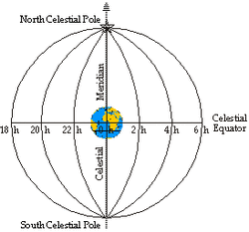
Right ascension. A star's position along a circle of constant declination is described by a second number called right ascension.
12. What does RA measure?
Measured in hours and minutes.
Instead of 360°, a circle is broken into 24 hours of right ascension.
So, 360° = 24 h R.A., 15° = 1 h R.A., and 1° = 4 min R.A.
13. How many degrees in 3 hours?
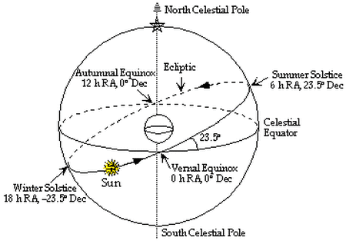
Ecliptic Once a year, the Sun traces out a circle on the celestial sphere called the ecliptic.
14. Moving north the sun crosses the celestial equator when?
15. Moving south the sun crosses the celestial equator when?

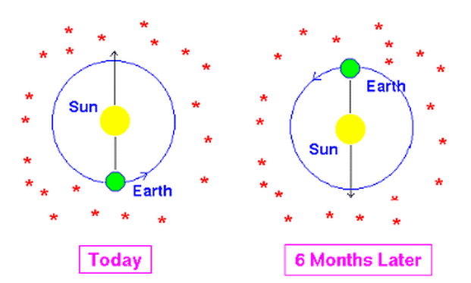
16. Why can't you see the same
constellations on the celestial equator all year round?
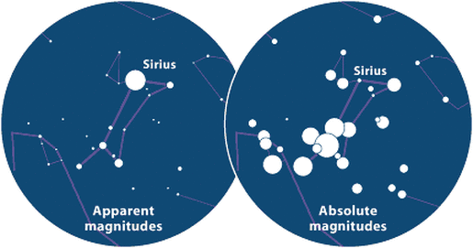
Apparent Magnitude how bright a star appears.
1st Magnitude Star is very bright.

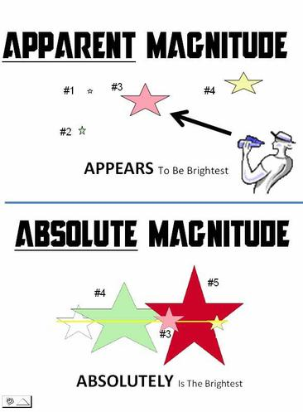
absolute magnitude comparing how bright stars are when placed side by side
at a distance of 10 parsecs (which is 32.6 light years) from the Earth.
17. Compare absolute and apparent magnitudes?

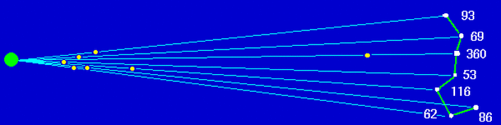
The 20 Brightest Stars in the Sky

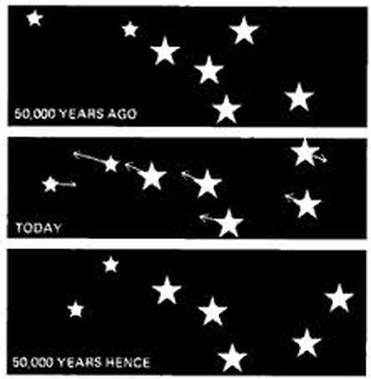
18. Why is a constellation not a flat image?
19. Why does the shape of a constellation change over time?
Messier
Messier 1

Create a free website with

