Star Blurr
The Star Link
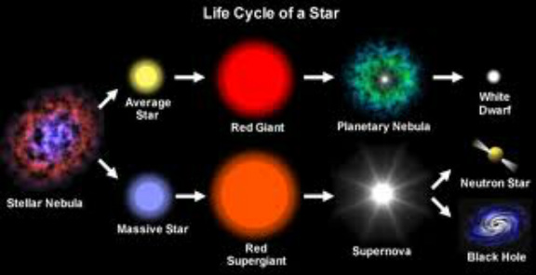
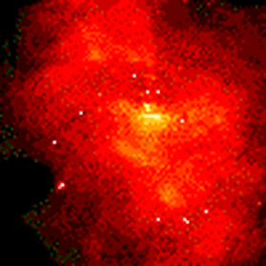
NEBULAE A stellar nursery is a nebula ( a large cloud of hydrogen gas in space) in which star formation is occurring (stars are formed from gas). These nebulae are frequently illuminated by ultraviolet light which is emitted from the newborn star. Link Link
1. Why is it called a stellar nursery?

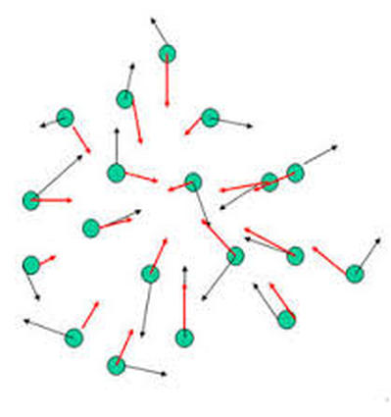
GRAVITATIONAL COLLAPSE
Gravitational collapse is when an object in space (like an interstellar cloud of dust) collapses under its own gravity. Link
2. What happens to gravity as the mass goes up?

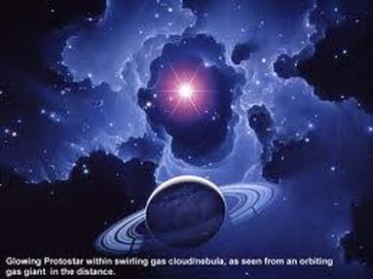
Protostar: link
The contracting cloud heats up due to friction and forms a glowing protostar; this stage lasts for roughly 50 million years. If there is enough material in the protostar, the gravitational collapse and the heating continue. If the heat becomes great enough 27million degrees F it will start to burn as a star.

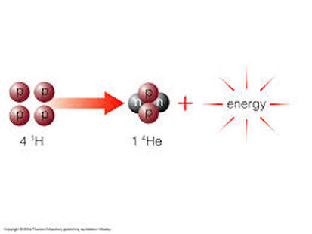
NUCLEAR FUSION Link
Nuclear fusion is an atomic reaction in which many nuclei (the centers of atoms) combine together to make a larger one (which is a different element). The result of this process is the release of a lot of energy (the resultant nucleus is smaller in mass than the sum of the ones that made it; the difference in mass is converted into energy by the equation E=mc2). Suns are powered by nuclear fusion, mostly converting hydrogen into helium. In this process, 4 hydrogen nuclei combine to form a single helium nucleus; about 0.3% of the original mass is converted into energy.
3. What is the total wt of 4 hydrogen atoms ?
4. What happens to the mass when 4 hydrogen make one helium?
5. What is the fuel of a star and what is the ash?

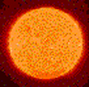
A Newborn Star
When a temperature of about 27,000,000°F is reached, nuclear fusion begins. This is the nuclear reaction in which hydrogen atoms are converted to helium atoms plus energy. This energy (radiation) production prevents further contraction of the star.
6. What happens at 27,000,000 degrees F?

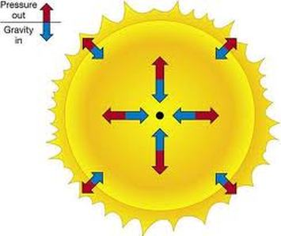
Middle Age Star
The star does not change in size because of the balanced forces.
7. What would happen if the force of gravity would take over?
8. What would happen if the for force of expansion took over?

Life span:
The most massive stars have the shortest lives. Stars that are 25 to 50 times that of the Sun live for only a few million years. They die so quickly because they burn massive amounts of nuclear fuel.
For example, Betelgeuse (the second-brightest star in Orion) is a red supergiant star that is about 20 times more massive than the Sun. It is about 14,000 times brighter than the Sun and burns nuclear fuel at a rate 14,000 times faster than than that of the Sun. The Sun will live about 7,000 times longer than a massive star like Betelgeuse.
Stars like our Sun live for about 10 billion years. Stars less massive than the Sun have even longer life spans.
Fate of a Star:
A star will become either a black dwarf, neutron star, or black hole, depending on how massive it was
9. Why do massive stars have shorter lives?
10. What determines how a star will end its life?
3 life Cycles of Stars
Sun-like Stars (Mass under 1.5 times the mass of the Sun) --> Red Giant --> Planetary Nebula -->White Dwarf --> Black Dwarf
Huge Stars (Mass between 1.5 to 3 times the mass of the Sun) --> Big RedGiant --> Nova --> Neutron Star
Giant Stars (Mass over 3 times the mass of the Sun) --> Super Red Giant --> Supernova --> Black Hole
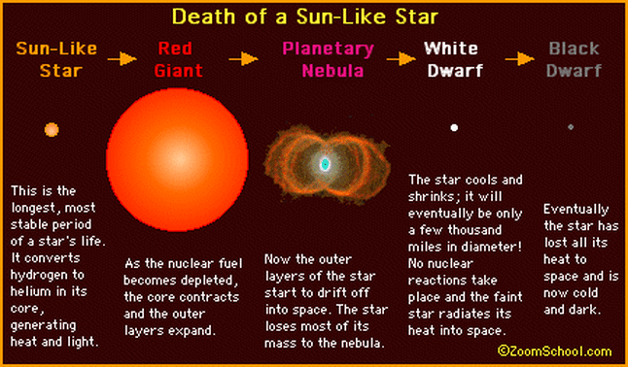
Death of a low or medium mass star.
Path N___, L____ R____ P_____ W ____ B_____
Fuel starts to run out.
11. During the life time of a low/medium mass why does it swell to a Red Giant?
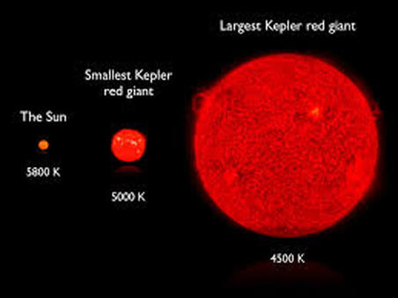
12. Why is a red giant red?
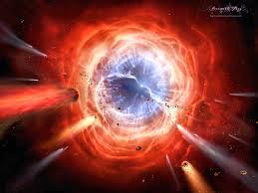
Planetary Nebula the outer layers of the star start to drift out into space.
13. Why do the outer layers start to drift away?
White Dwarf what is left over after ejection of gases and cooling. Link
14. What happens to the white dwarf and why?
Black Dwarf. just fades away.
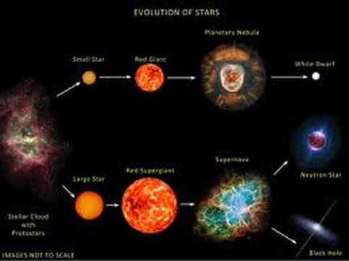
Path N____ L_____ S____ Nn_______ _________ nB ____ ____
Death of a High mass star Big noise, Bigger noise.
Large star to Super Red Giant Link
15. Why does it get so big?
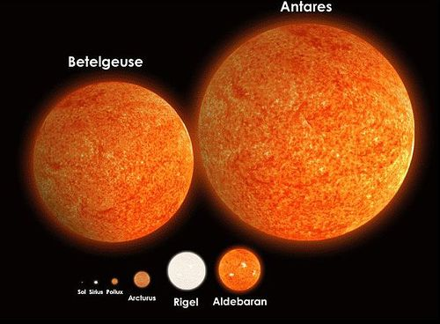
16. How might Aldebaran end it's life and why?
17, How might Betelgeuse end it's life and why?
18 How might Antares end it's life and why?
Neutron Star small high mass star. Link
Black Hole super high mass object that can not escape the gravity, not even light. Link
Link
19. Why do these objects have such super gravity?
20. Where is M82 and what is going on there?
Our Sun link
Something new and old Link
Moon Smack
Kepler Planets
Create a free website with

