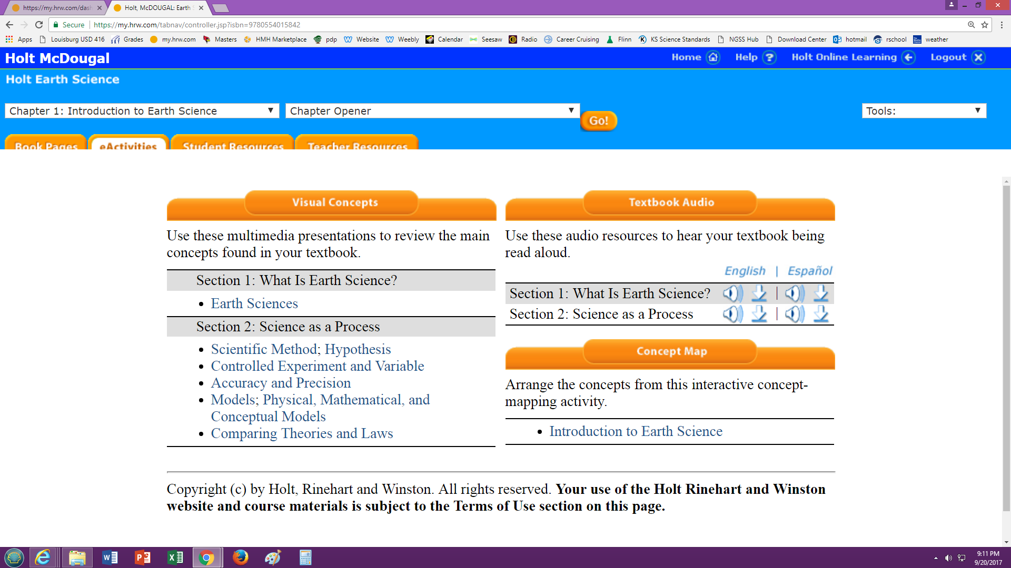

Go to Chapter 1, 2, and 3 Chapter Opener.
Go to eActivities.
Click each of the links below Section 1 and Section 2.
Make a google doc for you and your partner. Share it with Mrs. Stevens. Title it Chapter 1 Visual Concepts.
List what happens on each link.
Earth Sciences
Scientific Method
Hypothesis
Controlled Experiment and Variable
Accuracy and Precision
Models
Physical, Mathematical, and Conceptual Models
Comparing Theories and Laws
Continue doing the same for Chapters 2 and 3.

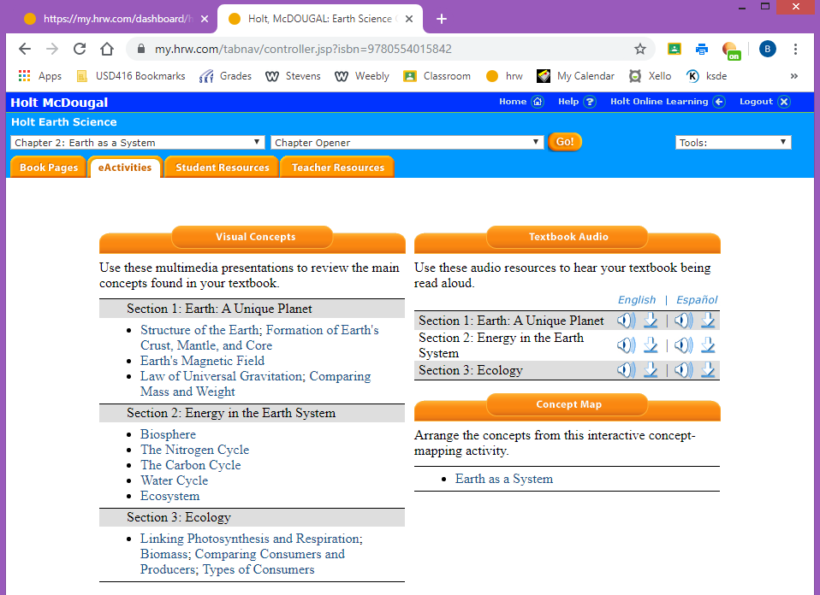

Chapter 2

Structure of the Earth
Formation of Earth’s Crust, Mantle, and Core
Earth’s Magnetic Field
Law of Universal Gravitation
Comparing Mass and Weight
Biosphere
The Nitrogen Cycle
The Carbon Cycle
Water Cycle
Ecosystem
Linking Photosynthesis and Respiration
Biomass
Comparing Consumers and Producers
Types of Consumers

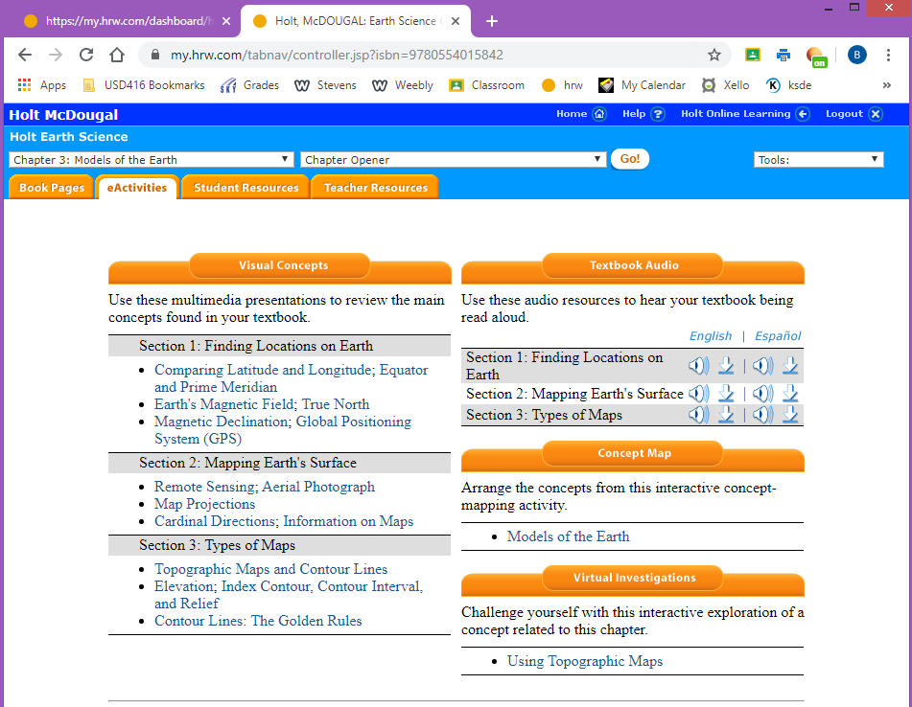

Chapter 3

Comparing Latitude and Longitude
Equator and Prime Meridian
Earth’s Magnetic Field
True North
Magnetic Declination
Global Positioning System (GPS)
Remote Sensing
Aerial Photograph
Map Projections
Cardinal Directions
Information on Maps
Topographic Maps and Contour Lines
Elevation
Index Contour, Contour Interval, and Relief
Contour Lines: The Golden Rules

