Tie Dye and Ice Cream Lab

- Tie Dye—students supply their own fabric

This is a reminder to bring your 100% white cotton item to school. No undergarments!
Put your initials on the tag or in a hidden spot with permanent marker.
I need it before class because it needs to soak for about an hour before we dye it.
At home, wash it in dish soap or hand soap. Bring it to school in a sealed container. Ziploc bags or plastic bowls work well.

QUICK EXPLANATION
OF THE CHEMICAL PROCESSES INVOLVED IN TIE-DYEING
Fiber reactive dyes attach permanently to cellulose fibers using a covalent (electron-sharing) bond. These molecules carry a "chromophore" which absorb varying spectrums of the light, allowing only certain spectrums to reflect.
Covalent bonding is the one of the most basic and strongest types of chemical reactions. This reaction happens gradually over time depending on temperature and/or the Ph level of the surrounding environment.
The Soda Ash pre-soak raises the pH level of the garment or fabric to approximately 10.5. Raising the pH level of the solution that the fabric or garment is soaked in raises the level of negative hydrogen ions in the dyeing environment. The chemical bonding process uses these ions in the reaction. Pre-soaking in Soda Ash fixer solution is what allows the fiber reactive dyes to work at room temperature.
The reaction can also be aided with heat. Some tie-dyers have had success with using baking soda and microwaving their dyed articles. Since baking soda is a weaker alkali than Soda Ash, it must be accompanied by heat. Some people who are "chemically sensitive" choose to use this method.
The dye is allowed to react in a desirable host environment for up to 24 hours. After this time, the bonding sites on the cellulose should be saturated with dye molecules. Excess dye molecules that have not bonded permanently are washed away using warm water rinse and a dye-carrying detergent like Synthrapol.

- Ice Cream—about $10 per batch

For Larger Classes: make 2 or 3 batches
Supplies | Approx. Price | Quantity | Container | Volunteer
½ and ½ | 4.00 | 4 cups | 1qt. carton
Cream | 4.00 | ½ cup | 1pt. or 1qt.
Sugar | 0.50 | ¾ cup | Bowl w/lid
Vanilla/Ice | 1.00 | 2 tsp |  | Stevens
Salt |  | Pinch | Bowl w/lid
Spoons | 1.00 | 20
Bowls/cups | 1.00 | 20
Machine |  | 1 or 2 |  | Stevens
Rock salt | 2.00 | 1 bag

QUICK EXPLANATION
OF THE CHEMICAL PROCESSES INVOLVED IN FREEZING POINT DEPRESSION
When you dissolve NaCl in water, it will have to take energy from the system to break its structure so it can dissolve in water. This is the reason the water gets colder, because the salt uses the energy from the water to dissolve in it. Now let’s look at why water melts when salt is added. This is based on a so called colligative attribute. These attributes are only dependent on the amount of substance. When you add particles to a solvent, its vapor pressure lowers. This will result in a higher boiling point (using salt for cooking) and a lower freezing temperature for the solution.

Freezing point depression
- Salt changes the freezing point of water from zero Celsius to below that
- -6°C is normally measured in KS
- Salt ions are between the water molecules making it harder for the solid to form
- Water can’t crystallize with the salt in the way
- IM forces between water molecules are reduced

Changes in States of Matter

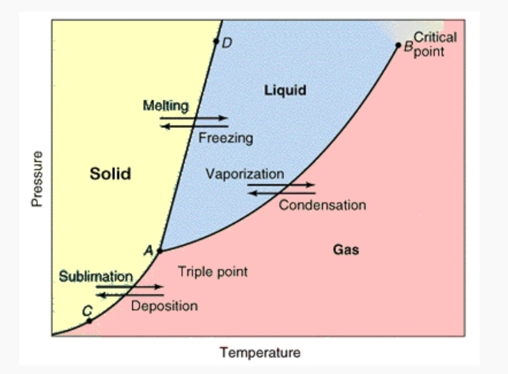
Heat of Vaporization
- energy is added
- boiling

Heat of Fusion
- energy is subtracted
- freezing

Evaporation
- energy is neither added nor subtracted
- it happens at all temps
- ice volume decreases in the freezer
- water volume decreases at room temp.

Cooling |  |  | Heating
State Change | Term | Examples | State Change | Term | Examples
liquid to solid | freezing | water to ice | solid to liquid | melting | ice to water
gas to liquid | condensation | fog, cloud | liquid to gas | vaporization | water to steam
gas to solid | deposition | frost, snow | solid to gas | sublimation | dry ice to CO₂

- Why did we tie dye? Use complete sentences and highlight these words:
Acid, Base, Neutralization, Salt, Water, pH, pOH
__________________________________________________________________________________________________
__________________________________________________________________________________________________
__________________________________________________________________________________________________
__________________________________________________________________________________________________
__________________________________________________________________________________________________
__________________________________________________________________________________________________
__________________________________________________________________________________________________
__________________________________________________________________________________________________
__________________________________________________________________________________________________
__________________________________________________________________________________________________
__________________________________________________________________________________________________

- Why did we make ice cream? Use complete sentences and highlight these words:
IM Forces, Strong, Weak, Salt, Ice, Solid, Liquid, Freezing Point Depression
__________________________________________________________________________________________________
__________________________________________________________________________________________________
__________________________________________________________________________________________________
__________________________________________________________________________________________________
__________________________________________________________________________________________________
__________________________________________________________________________________________________
__________________________________________________________________________________________________
__________________________________________________________________________________________________
__________________________________________________________________________________________________
__________________________________________________________________________________________________

