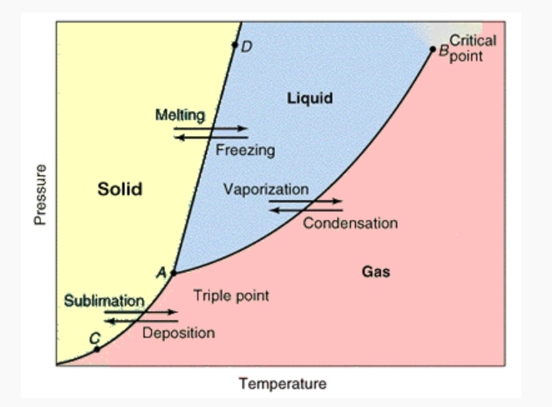

Make a graphic organizer to show the phase changes and the names of how those phases change.
EX. How does solid turn to liquid? Melting. SL Melting

